HTML 5 & JavaScript: Campsite Booking Application.

Project Team.

**B00278705**

**B00291618**

The Application.

We developed an online campsite booking application, this app would allow the user to select different types of accommodation , choose their arrival and departure dates, select how many adults and children would be in the party, The app will calculate the cost of the stay by taking the price of the accommodation and multiplying it by the number of nights they are staying for, it will then allow the user to enter their full name, address, postcode, telephone number and email address.

The app also allows the user to view photos of the campsite, view and retrieve previous bookings they have made, and cancel a booking if required. It also features a section that will allow the user to select from a list of local activities and display their location on a google map, finally there is a feature that will allow the user to leave a comment and also view comments previously left by other holiday makers.

Design Changes.

The original design was basic and cluttered and we felt that a few changes were necessary, The major changes were the introduction of panels this gave us the ability to include more content in the panels but hide them if they were not needed at the time, this reduced the cluttered look of the original, we then introduced a video background which give the site a modern and professional appearance, this did however cause some additional issues with regards to the text and how that appeared on top of the background, we overcame this by making the panels the text resides on opaque so that the video did not distract the user too much and the text was easily readable.

Variables and Types amendments.

Items Added:

* ******* WILL DO THIS LATER ********

Items Removed:

* ******* WILL DO THIS LATER ********

Testing.

We implemented several testing strategies to enable us to test the functionality, usability, and compatibility of the app. Testing was undertaken at various stages of the development and at key points in the life cycle of the app. The tests were introduced before we would proceed onto the next section with the exception of compatibility as this was left until the app was complete.

Functionality:

* Validation of date fields to ensure dates were after current date and departure date was after arrival date.
* Validation that at least 1 adult will be included in the party.
* Validation of telephone number was 11 digits long.
* Validation that email address entered was in the correct format.
* Correct booking displayed when selected.

Usability:

* All panels opened and closed correctly and displayed their correct content.
* All buttons operated in the correct manor.
* Price and number of nights updated as booking was changed.
* Number of adults and number of children updated when sliders moved.
* All photos displayed correctly.
* Video played correctly.
* Bookings displayed correctly and in the correct panel.
* Map updated when local activity selected.
* Text updated when local activity selected.
* Comments displayed correctly and in the correct panel.

Compatibility:

* Check all functions worked with Internet Explorer.
* Check all functions worked with Firefox.
* Check all functions worked with Safari.
* Check all functions worked with Google Chrome.

Test Data.

******* WILL DO THIS LATER ********

Test Results.

The tests were completed in stages, only when these were fixed would we proceed.

Stage one: Cost did not update.

Arrival Date allowed before departure date if accommodation changed.

Telephone number validation fail.

Number of adults not validated.

Map did not display correctly.

Local activities panel would not close.

Booking data displayed incorrectly.

Text displayed in wrong font.

Photos displayed in the wrong location.

Stage two: Could not select correct booking.

Email not sending after booking.

Price displayed as NaN if input data was invalid.

Number of nights displayed as NaN if input data was invalid.

Panel headings would not change when selected.

Stage 3: ******* WILL DO THIS LATER ********

ScreenShots.

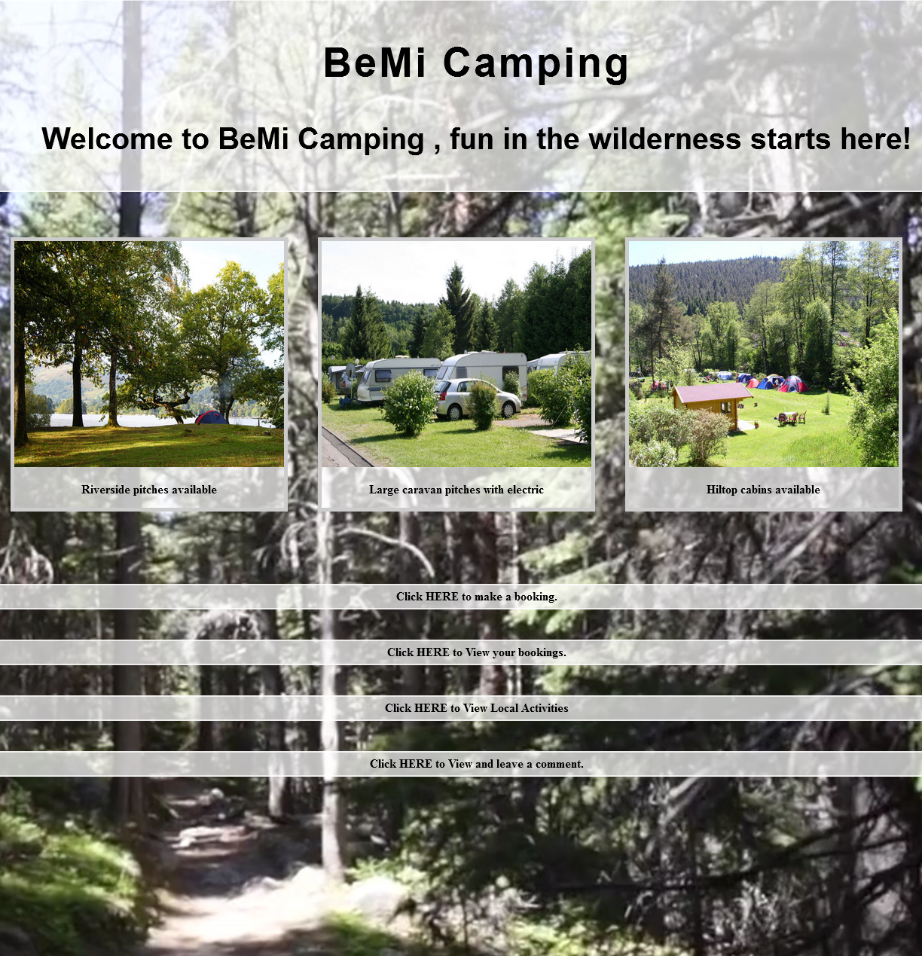

Team Work.

Both of us fulfilled the roles that were required of us in a timely and professional manner, we had weekly meetings and had plenty of contact over email, we worked closely together through all stages of the development of this app, we helped each other in the areas of programming that were difficult and we both give 100% to the development of this web app, we both feel we have learned a lot from working in a team as we come from different backgrounds and are of different age groups, we feel this has developed our team skills enormously as this is how it would be in the workplace.

Team Meeting Minutes ?????????????????????